PRESS RELEASE- Embargo 9am Thursday 27 March 2014, Naples, Italy & Birmingham, UK:
Anglo-Italian Deal Aims to Disrupt UK eLearning Market
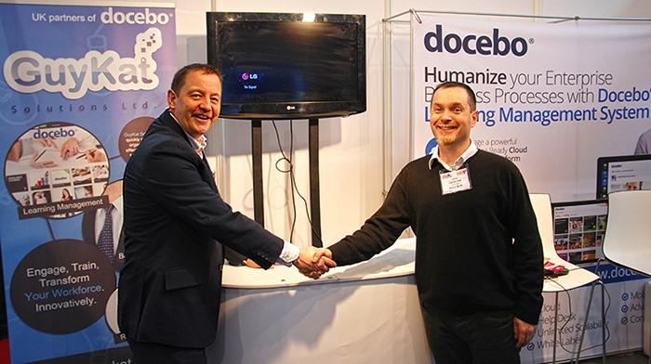

After weeks of rumour it can be confirmed: Birmingham based GuyKat Solutions Ltd. has signed an exclusive UK & Ireland partnership agreement with Naples-based Docebo SPA, the global E-Learning SaaS solutions provider.

GuyKat MD, Guy McEvoy said; “We’re on the cusp of an explosion of eLearning in the workplace. Classroom-based training is often expensive and inefficient but people have historically been put-off eLearning by poor content and cost. We’re ripping up those barriers. Docebo is the right product at the right time. It’s a cloud-based ‘Software-as-a-Service’ solution. It combines ease-of-use with enterprise grade features at a fraction of the traditional cost. The pricing model is already a ‘no-brainer’ for large organisations and we’re now making this type of enterprise-grade capability affordable to the SME market. We’re privileged to bring this game changer to the UK and Ireland.”

The deal is a key milestone in the growth plans of both businesses, with Docebo further establishing its presence in the UK market, and GuyKat deepening its solution offering.

Claudio Erba, CEO & Founder of Docebo, states:“Docebo is globally disrupting the E-Learning market, by replacing the old “E-Learning project” legacy with a new, agile and affordable “E-Learning service”, accessible and tailored for both Mid-sized and Large Enterprises, literally within minutes. The partnership with GuyKat Solutions Ltd. is an unprecedented opportunity for UK based companies to access a comprehensive solution that offers a fully featured E-Learning Ecosystem.”

ENDS

About Docebo SPA
Docebo is a disruptive Cloud E-Learning solutions provider that is revolutionizing the online training market with its Software as a Service Learning Management System. Established in 2005, Docebo has over 28,000 installations worldwide, and is sold in more than 65 countries around the world. The Docebo LMS offers an enterprise solution for mid-sized to large organizations. Customers benefit from Docebo solutions thanks to a scalable pricing model, a third party integration (via API), and reliable service available 24/7 to further enhance the user experience. For more information, visit www.Docebo.com, contact Dario De Angelis at +39 039.2323286 or email press@docebo.com

About GuyKat Solutions Ltd:
GuyKat is a Birmingham headquartered Learning Technology Company specialising in corporate bespoke eLearning. The company was founded in 2009 and is based at Innovation Campus Birmingham. The company has been in a strategic partnership with Docebo since 2011. This deal sees exclusivity for the territories of the UK & Ireland. Website: www.guykat.com

